Members at the meeting: Russ Altman, Misty Bauer, Melissa Bravener, Luke Bravener, Brandon Bravener, Caleb Conner, Robert Dombrowski, Derek Godard, Hallie Grosskreutz, Tyler Grosskreutz, Andy Guldan, Roy Koopman, Heidi Kundinger, Lily Mater, Evan Scholl, Bill Wildenberg, Kyle Wildenberg

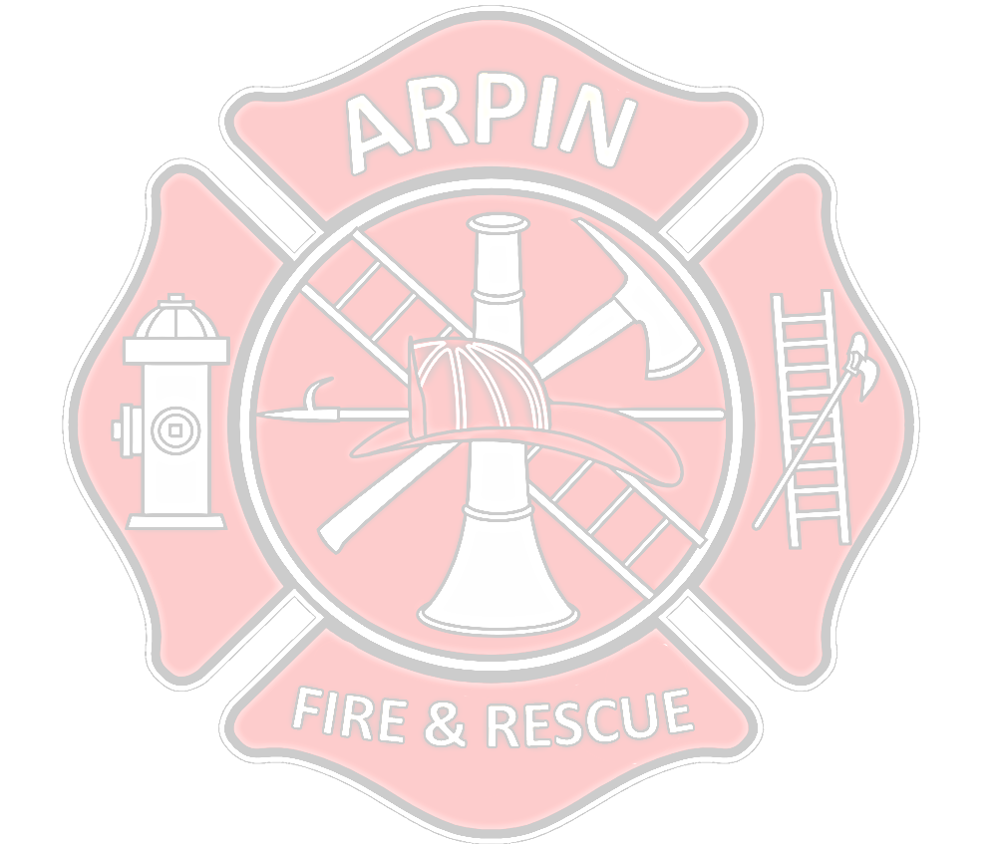
Meeting started at 7:15PM

Robert made a motion to accept the minutes from the previous meeting. Heidi seconded the motion. M/C.
Robert made a motion to accept the Financial Report. Heidi seconded the motion. M/C
Please make sure that all your wildland gear is ready to go as this is wildland season upon us.
Auburndale Fire Department will be holding “Water Fights” in Auburndale on May 17th, 2025, at 10:00AM
- They also want people to bring their engines so they can shuttle water.
The next fire class will be held at Midstate in August of 2025. New members that haven’t done a fire class will need to take it.
This week is National Dispatch Week, we are encouraged to send a card to dispatch, and let them know that we appreciate it.
Zone Map Books are in and ready for pick up.
- Luke and Tyler will be picking the books up at the Chief’s meeting that is held this Thursday at Emergency Management Center.
- They will also be getting an App made so its easier for view if for some reason you can’t find the book. The App will be updated as new houses/businesses are made.
- Once the new books are in the trucks, we can disregard the old ones.
Helicopter communications will remain on MARC2 not FG Gray. There are certain Fire Departments that don’t have FG Grey on their Radio’s.
The rehab trailer needs to go through to ensure that everything is working and if not, replace the batteries on them.
Hewitt will be burning their tall grass at their fire training center this Wednesday.
- Let Luke know ASAP if you want to go so, he can let Hewitt’s Chief know how many people are coming from Arpin.
- We don’t need to bring any trucks as they will have all the equipment there.
2% Audit went well – Please make sure you are signing your name at all meetings, trainings etc.
We will have a work night coming up so we can keep going through the old items.
Hallie and Tyler will bring the Food for the next meeting.
Tyler made a motion to adjourn the meeting, Robert seconded the motion. M/C
Meeting ended at 7:25PM

